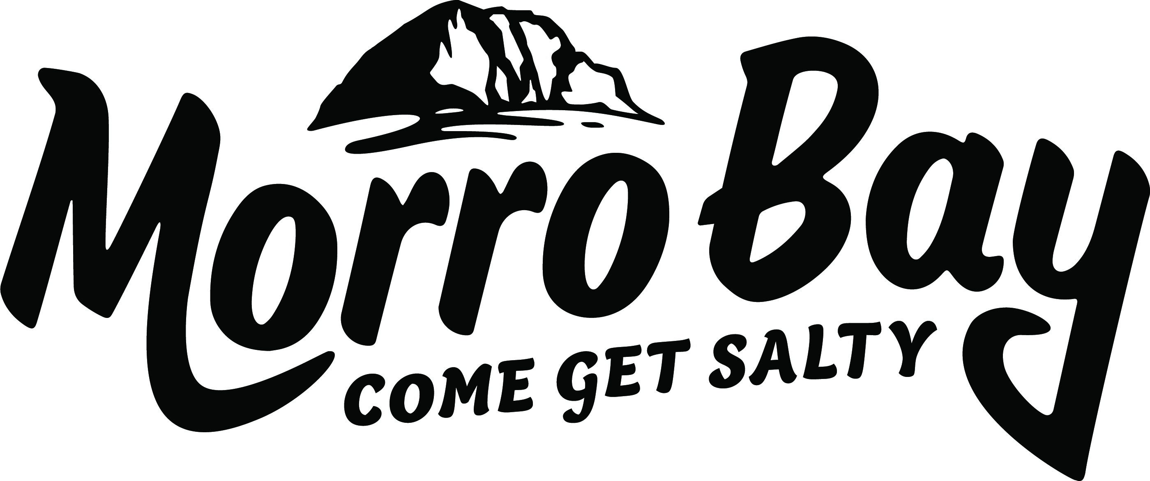
Agenda
Visit Morro Bay Board of Directors

Visit Morro Bay Board of Directors Agenda
Thursday, March 12, 2026
9:00 am – 11:00 am
Visit Morro Bay Office - 695 Harbor St. Morro Bay
- CALL TO ORDER
- PUBLIC COMMENT (On Non-Agenda Items)

ANNOUNCEMENTS M. Wambolt

EXECUTIVE DIRECTOR REPORT M. Wambolt

- Executive Director Report (20 min)
Staff will provide an update on current projects, reporting and areas of focus for the months ahead
CONSENT AGENDA – motion required M. Wambolt

- Approval of January 22, 2026, Meetings Minutes
- Approval of Visit Morro Bay Financials
BUSINESS ITEMS & DISCUSSIONS M. Wambolt M. Wambolt

- Visit Morro Bay Transition Sub-Committee Update
Transition Sub-Committee to give update of the executive director recruitment. Board to hear sub-committee decision.

- Visit Morro Bay Approval of Attorney of Record (5 mins) motion required
Staff to recommend an attorney of record. Board to approve attorney of record.

- Morro Bay in Bloom – I LOVE Morro Bay – Grant - $5,000 (10 mins) motion required
Walter Heath from Morro Bay in Bloom to present grant request. Board to discuss and potentially approve funds.

- Morro Bay Car Show Sponsorship Approval - $5,000 (10 mins) motion required
Crusin’ Morro Car Show will present grant request. Board to discuss and potentially approve funds.

- Morro Bay 4th of July Drone Show Discussion. (15mins)
Staff to and City to present a Drone Show opportunity for the 4th of July. Board to discuss next steps.

- Maritime Museum Endorsement – Triangle Lot included in Harbor Master Plan (15 mins) motion required
Ron Reisner will present a requested endorsement from VMB to include the triangle lot in the Harbor Master Plan. Board to discuss and potentially approve board endorsement.

- Morro Bay Kite Festival Update and Funds Approval – Extra $5,000 (10 mins) motion required
Staff to give updates on Kite Festival and present the need for extra funds. Board to discuss and approve.

- Next Board of Directors meeting – May 28, 2026, 9:00am-11:00am – Visit Morro Bay Office

ADJOURN.

Brown Act Notice: Each speaker is limited to two minutes of public comment for items not on the agenda. Public comment for each agenda item will be called for separately and is also limited to 2 minutes per speaker. State law does not allow the Board of Directors to discuss or take action on issues not on the agenda, except that member of the Board may briefly respond to statements made or questions posed by the person giving public comment. Staff may be directed by the Board to follow up on such items and/or place them on the next Board agenda. The order of agenda items is listed for reference and items may be taken in any order deemed appropriate by the Board.

ADA Notice: Meeting facilities are accessible to persons with disabilities. If you require special assistance to participate in the meeting, notify Liz Gilson at (805) 225-7411 at least 48 hours prior to the meeting.

