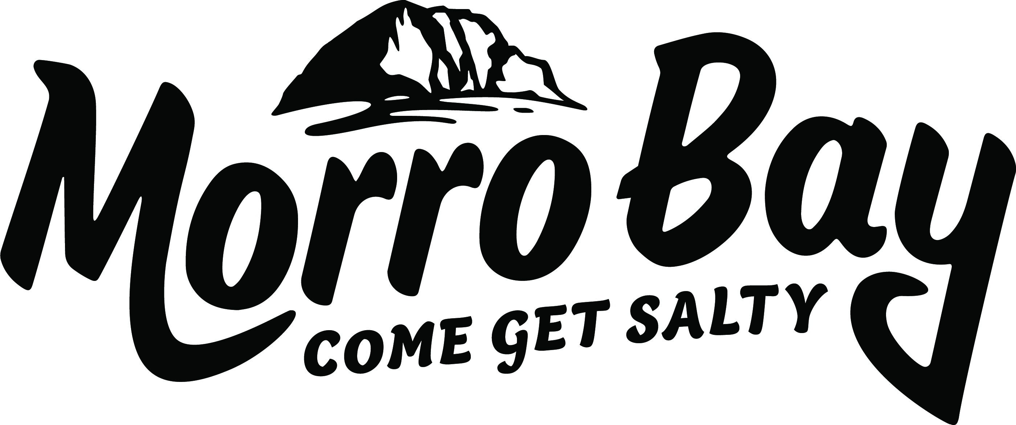
Agenda
Visit Morro Bay Board of Directors

Visit Morro Bay Board of Directors Agenda
Thursday, January 22, 2026
9:00 am – 11:00 am
Visit Morro Bay Office - 695 Harbor St. Morro Bay
- CALL TO ORDER
- PUBLIC COMMENT (On Non-Agenda Items)

ANNOUNCEMENTS M. Wambolt

EXECUTIVE DIRECTOR REPORT M. Wambolt

- Executive Director Report (20 min)
Staff will provide an update on current projects, reporting and areas of focus for the months ahead
CONSENT AGENDA – motion required M. Wambolt

- Approval of Nov 27, 2025
- Approval of Visit Morro Bay Financials
BUSINESS ITEMS & DISCUSSIONS M. Wambolt M. Wambolt

- SnapSea Website UGC Approval - (20 mins) motion required
Staff to present SnapSea UGC add on to the VMB website. Board to discuss and approve.

- Abbi Agency Marketing Update (25min)
Abbi Agency to give marketing update.

- Visit Morro Bay Billboard Sub-committee (10 mins) motion required
Board to approve Hwy 1 Billboard Sub-committee for annual billboard update.

- Visit Morro Bay Executive Director MBTBID Renewal Bonus Approval (20 mins) motion required
Board to discuss renewal of MBTBID bonus for the executive director. Board to potentially approve up to a 20% bonus.

- Approval of Moving March VMB Board Meeting - (10mins)
Due to travel conflicts staff are recommending moving March board meeting to March 12 or 19. Board to discuss and approve new date.

- Next Board of Directors meeting – TBD – Visit Morro Bay Office

ADJOURN.

Brown Act Notice: Each speaker is limited to two minutes of public comment for items not on the agenda. Public comment for each agenda item will be called for separately and is also limited to 2 minutes per speaker. State law does not allow the Board of Directors to discuss or take action on issues not on the agenda, except that member of the Board may briefly respond to statements made or questions posed by the person giving public comment. Staff may be directed by the Board to follow up on such items and/or place them on the next Board agenda. The order of agenda items is listed for reference and items may be taken in any order deemed appropriate by the Board.

ADA Notice: Meeting facilities are accessible to persons with disabilities. If you require special assistance to participate in the meeting, notify Liz Gilson at (805) 225-7411 at least 48 hours prior to the meeting.

